Test Case: tc002_SPX_Dev5_Crear_Requisicion_Spot_Con_FAD_Tipo_Cobro_CC
Step 1 - Enter username and password and click to button Enter : Credentials Entered
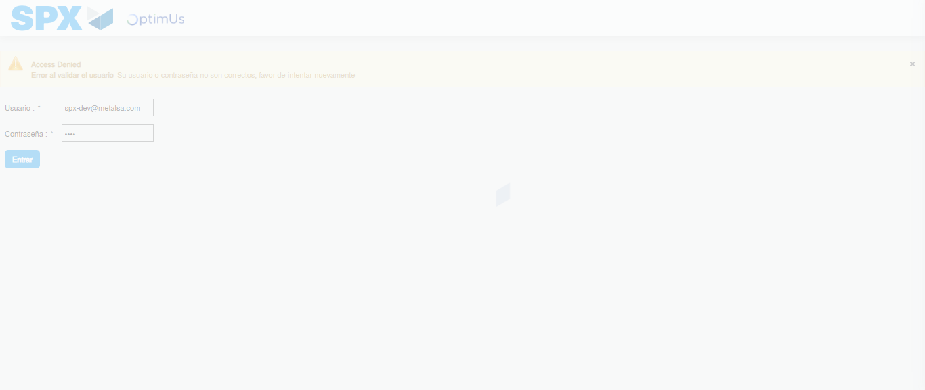Image file-name: QC_Testing-tc002_SPX_Dev5_Crear_Requisicion_Spot_Con_FAD_Tipo_Cobro_CC-1790179084668

Step 2 - Select to UEN and Access to Spot Buy Requisitions : UEN Correctly selected and Correct access
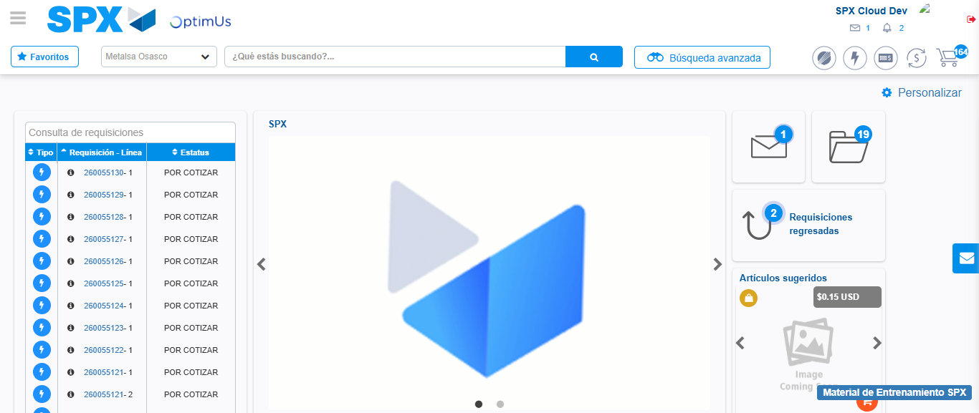Image file-name: QC_Testing-tc002_SPX_Dev5_Crear_Requisicion_Spot_Con_FAD_Tipo_Cobro_CC-1790179114815

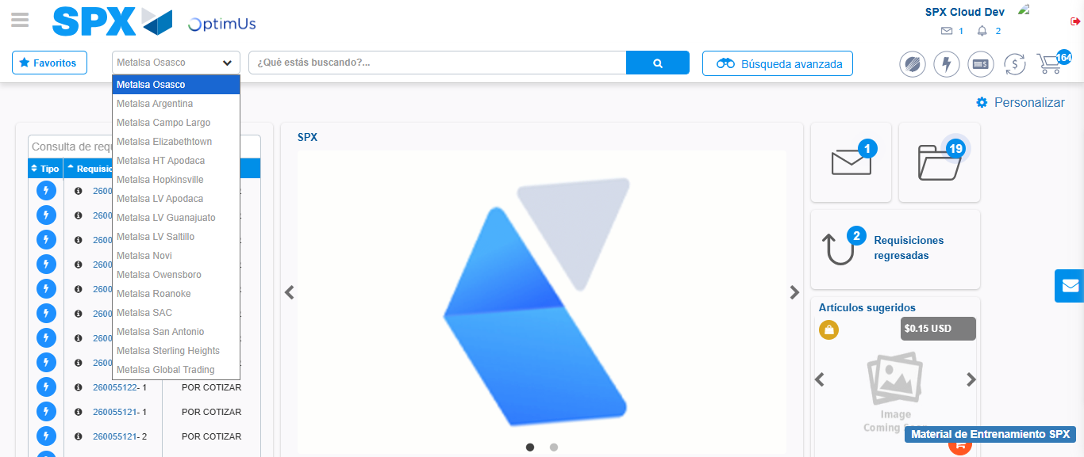Image file-name: QC_Testing-tc002_SPX_Dev5_Crear_Requisicion_Spot_Con_FAD_Tipo_Cobro_CC-1790179115303

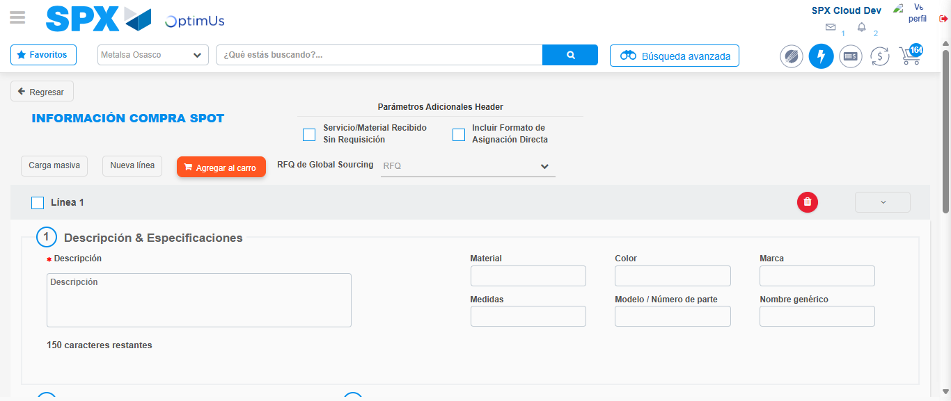Image file-name: QC_Testing-tc002_SPX_Dev5_Crear_Requisicion_Spot_Con_FAD_Tipo_Cobro_CC-1790179119370

Step 3 - Add FAD to Requisition: FAD Successfully Added
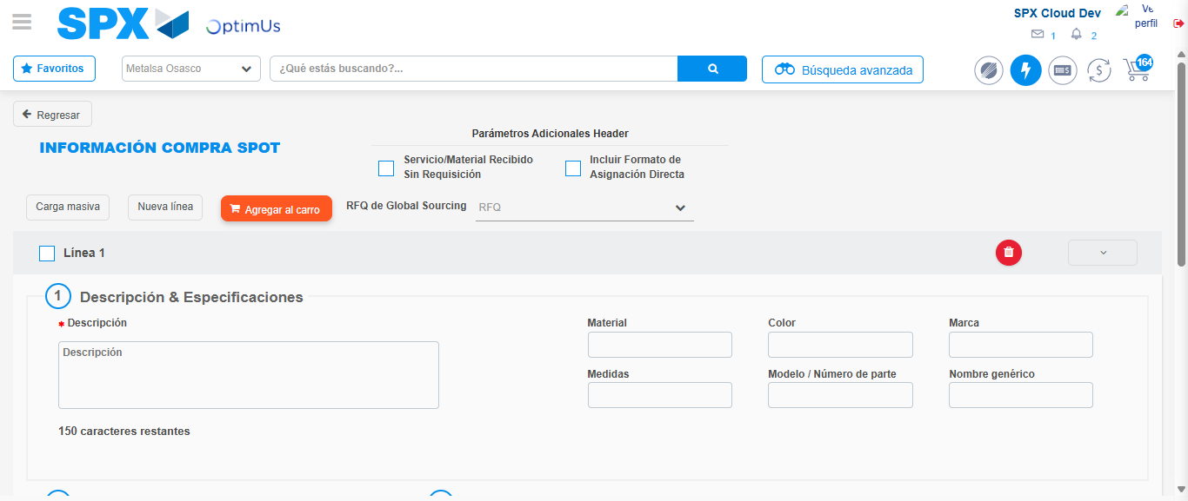Image file-name: QC_Testing-tc002_SPX_Dev5_Crear_Requisicion_Spot_Con_FAD_Tipo_Cobro_CC-1790179119635

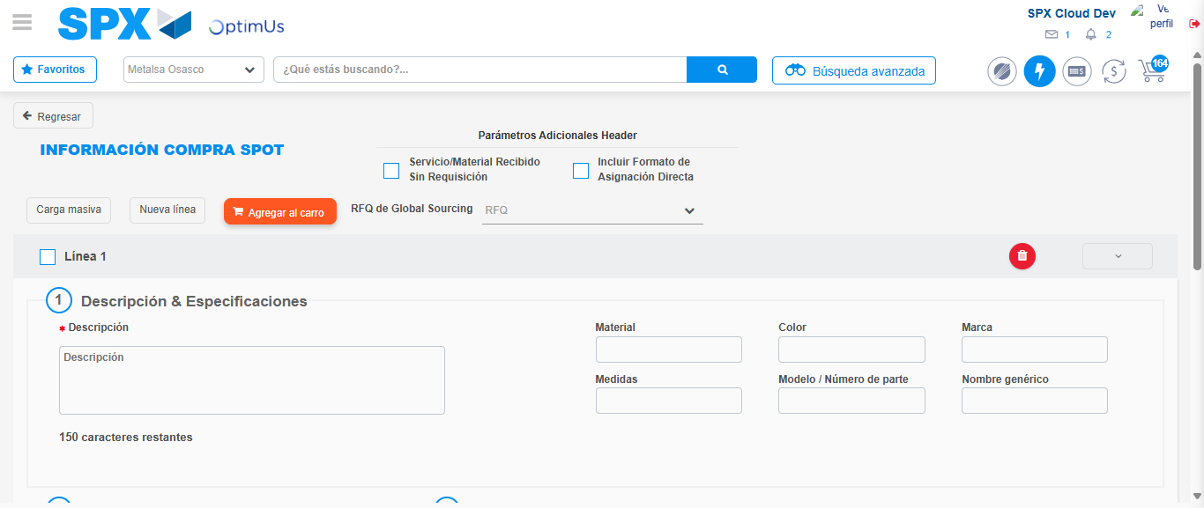Image file-name: QC_Testing-tc002_SPX_Dev5_Crear_Requisicion_Spot_Con_FAD_Tipo_Cobro_CC-1790179119853

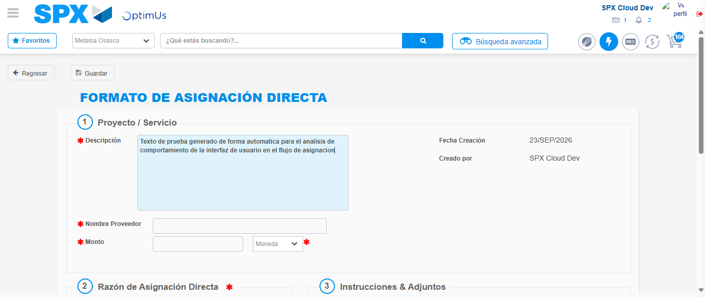Image file-name: QC_Testing-tc002_SPX_Dev5_Crear_Requisicion_Spot_Con_FAD_Tipo_Cobro_CC-1790179122492

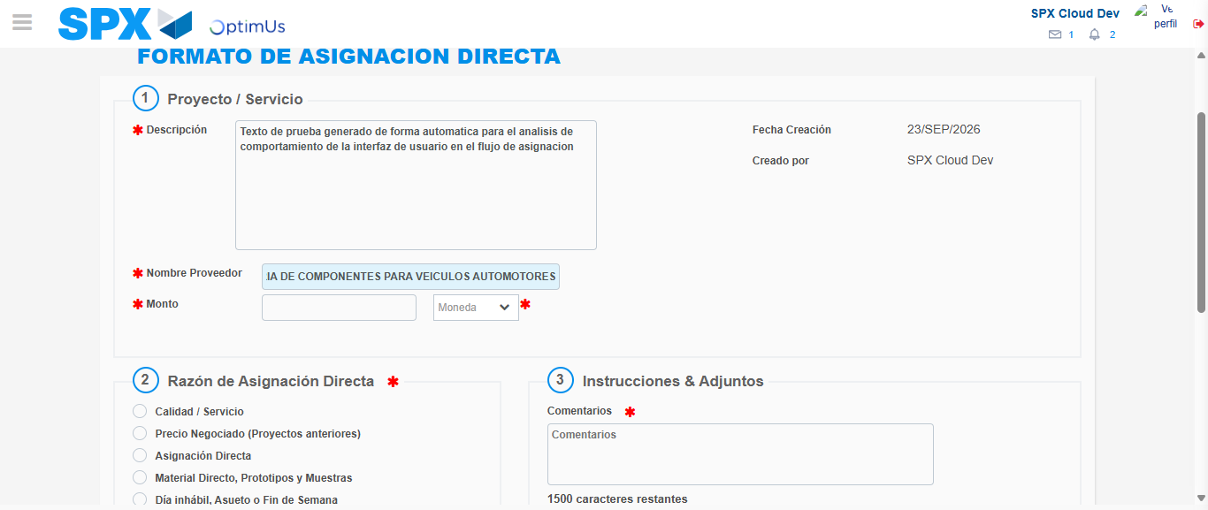Image file-name: QC_Testing-tc002_SPX_Dev5_Crear_Requisicion_Spot_Con_FAD_Tipo_Cobro_CC-1790179130723

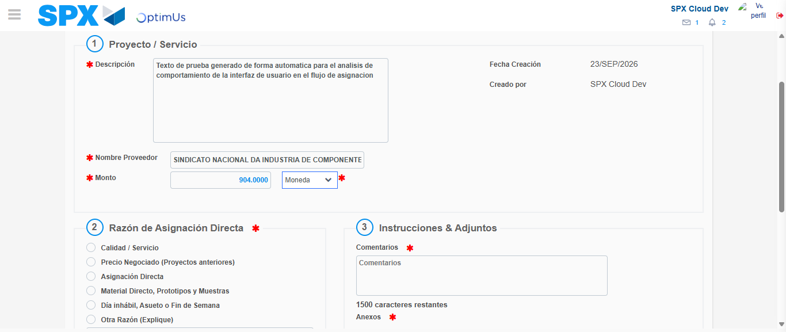Image file-name: QC_Testing-tc002_SPX_Dev5_Crear_Requisicion_Spot_Con_FAD_Tipo_Cobro_CC-1790179131103

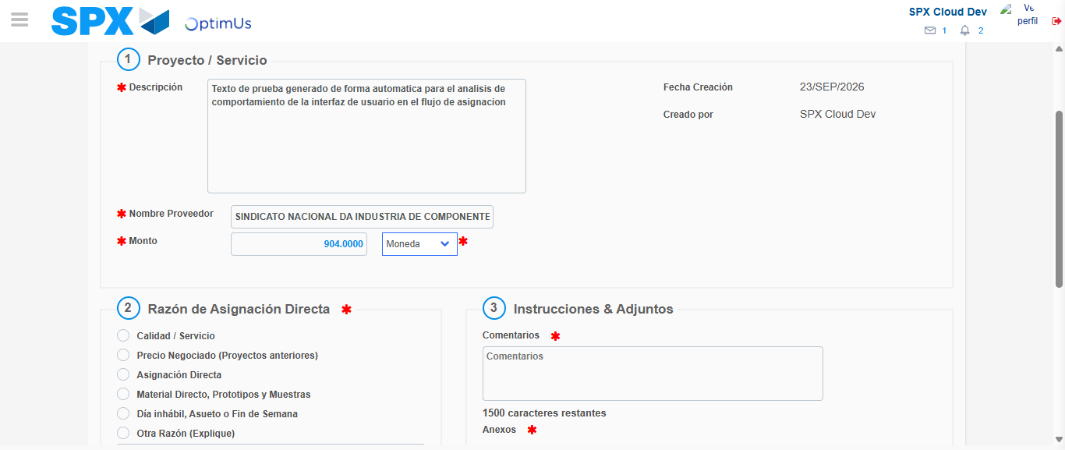Image file-name: QC_Testing-tc002_SPX_Dev5_Crear_Requisicion_Spot_Con_FAD_Tipo_Cobro_CC-1790179131308

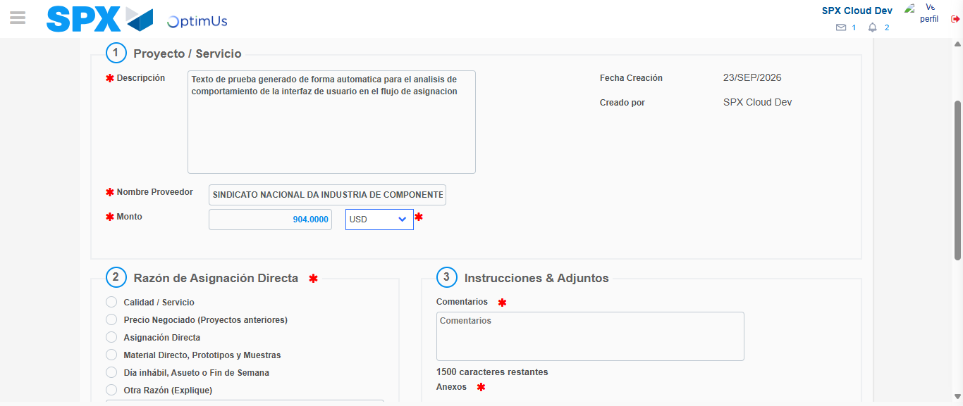Image file-name: QC_Testing-tc002_SPX_Dev5_Crear_Requisicion_Spot_Con_FAD_Tipo_Cobro_CC-1790179131573

Image file-name: QC_Testing-tc002_SPX_Dev5_Crear_Requisicion_Spot_Con_FAD_Tipo_Cobro_CC-1790179131742

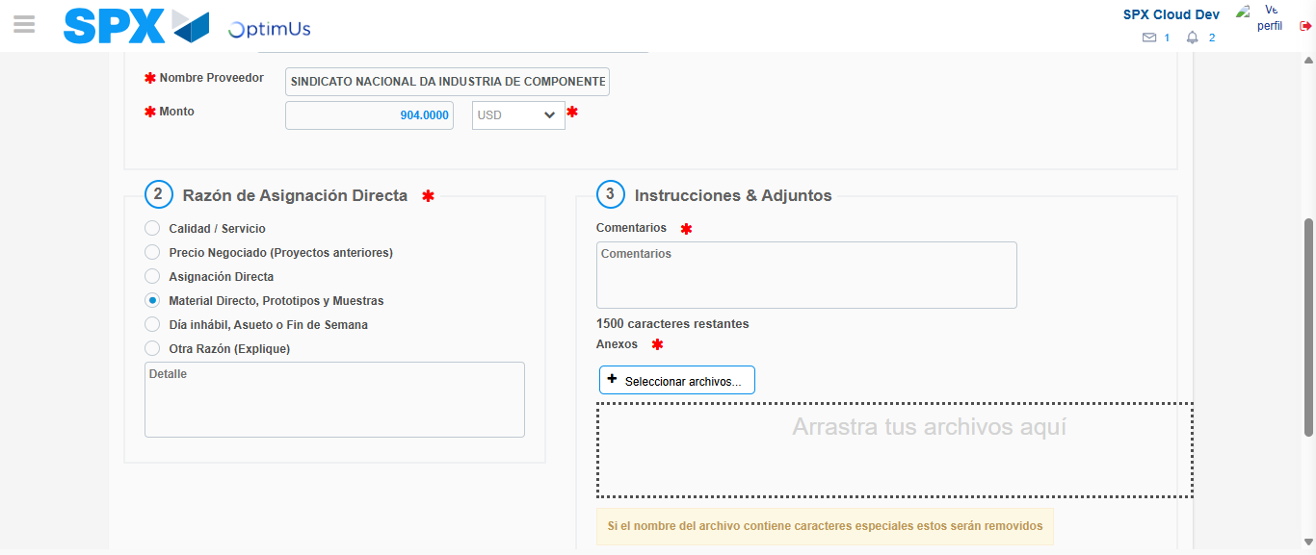Image file-name: QC_Testing-tc002_SPX_Dev5_Crear_Requisicion_Spot_Con_FAD_Tipo_Cobro_CC-1790179132540

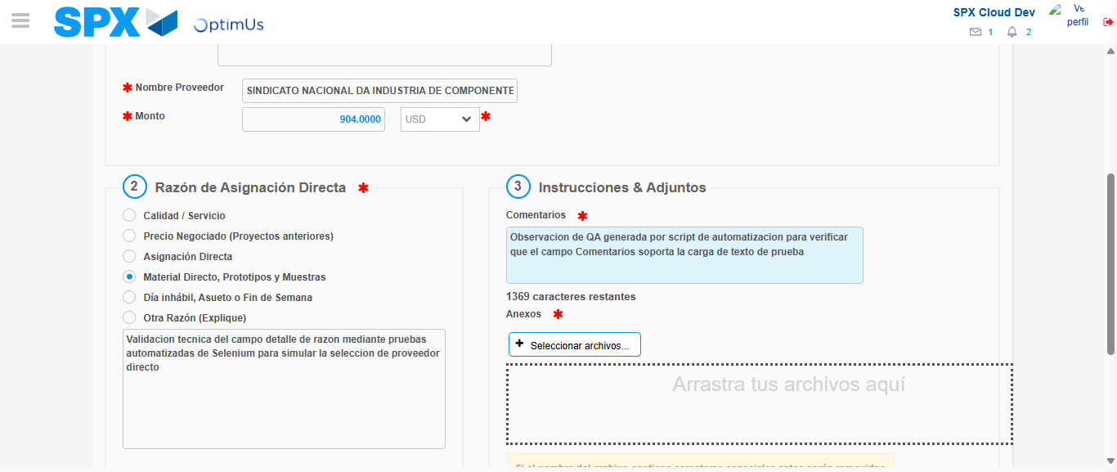Image file-name: QC_Testing-tc002_SPX_Dev5_Crear_Requisicion_Spot_Con_FAD_Tipo_Cobro_CC-1790179143468

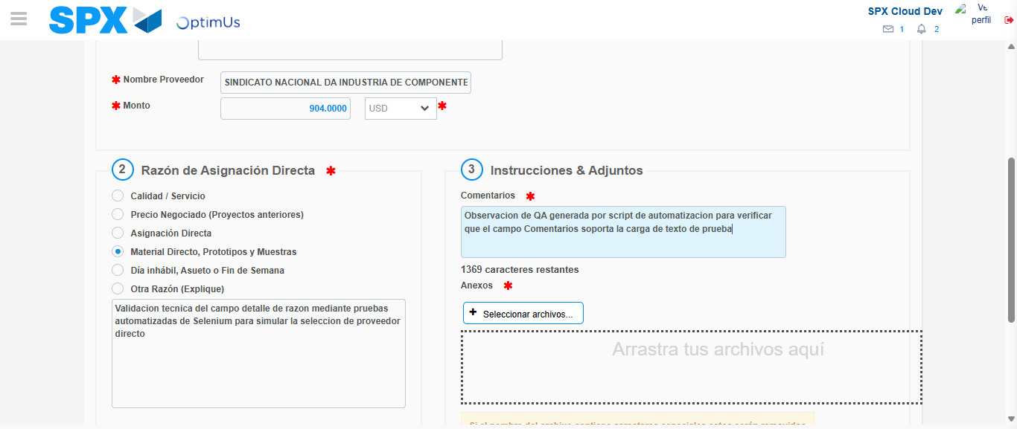Image file-name: QC_Testing-tc002_SPX_Dev5_Crear_Requisicion_Spot_Con_FAD_Tipo_Cobro_CC-1790179144015

Step 4 - Data Capture Spot Buy Requisition: Data captured correctly
Image file-name: QC_Testing-tc002_SPX_Dev5_Crear_Requisicion_Spot_Con_FAD_Tipo_Cobro_CC-1790179119635

Image file-name: QC_Testing-tc002_SPX_Dev5_Crear_Requisicion_Spot_Con_FAD_Tipo_Cobro_CC-1790179119853

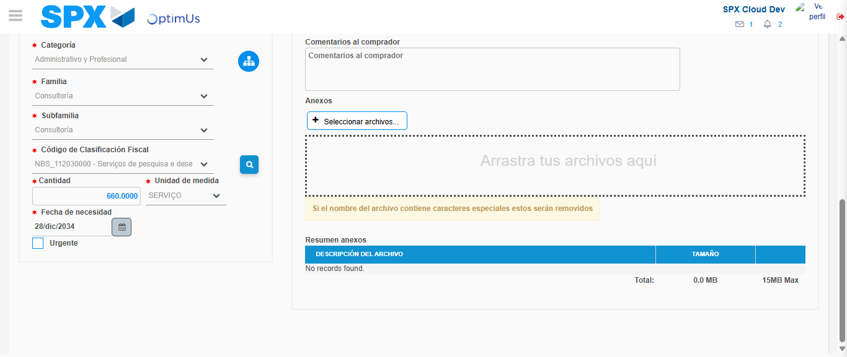Image file-name: QC_Testing-tc002_SPX_Dev5_Crear_Requisicion_Spot_Con_FAD_Tipo_Cobro_CC-1790179161790

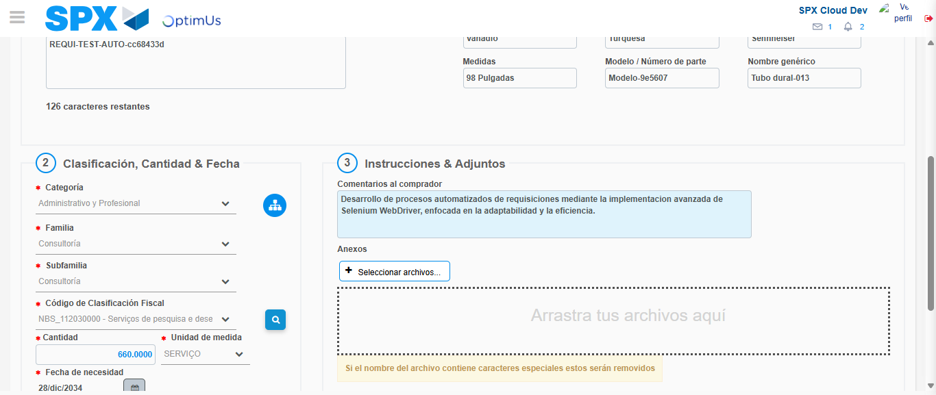Image file-name: QC_Testing-tc002_SPX_Dev5_Crear_Requisicion_Spot_Con_FAD_Tipo_Cobro_CC-1790179172500

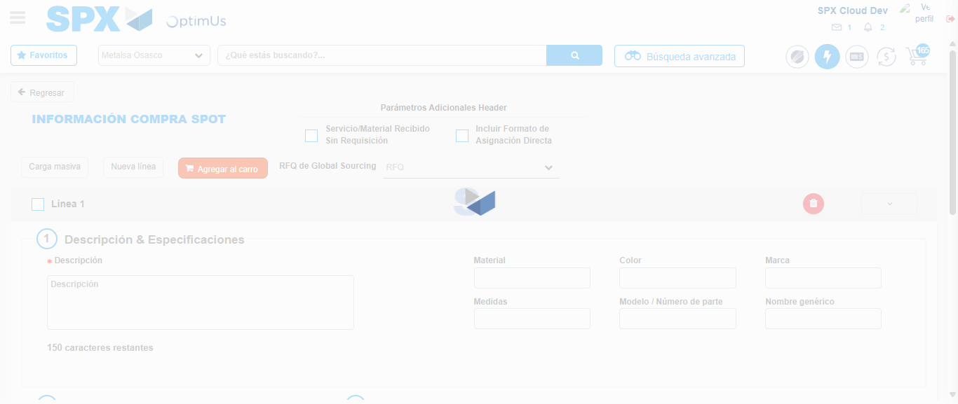Image file-name: QC_Testing-tc002_SPX_Dev5_Crear_Requisicion_Spot_Con_FAD_Tipo_Cobro_CC-1790179185263

Step 8 - Return to Main Page SPX : Return to Main Page SPX
Image file-name: QC_Testing-tc002_SPX_Dev5_Crear_Requisicion_Spot_Con_FAD_Tipo_Cobro_CC-1790179114815

Image file-name: QC_Testing-tc002_SPX_Dev5_Crear_Requisicion_Spot_Con_FAD_Tipo_Cobro_CC-1790179115303

Image file-name: QC_Testing-tc002_SPX_Dev5_Crear_Requisicion_Spot_Con_FAD_Tipo_Cobro_CC-1790179119370

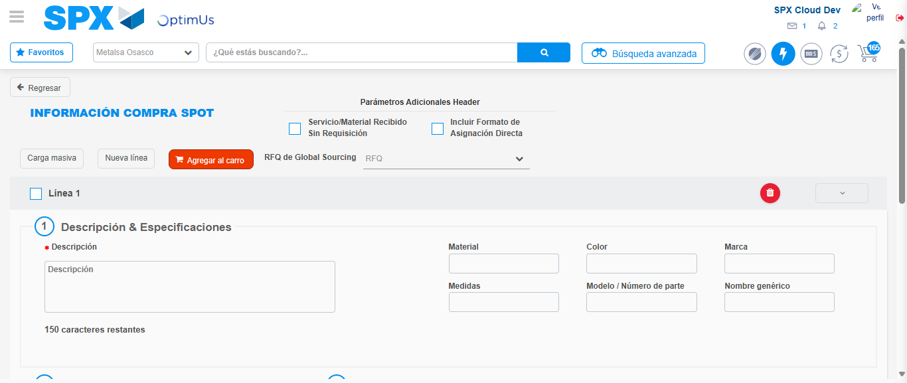Image file-name: QC_Testing-tc002_SPX_Dev5_Crear_Requisicion_Spot_Con_FAD_Tipo_Cobro_CC-1790179187462

Image file-name: QC_Testing-tc002_SPX_Dev5_Crear_Requisicion_Spot_Con_FAD_Tipo_Cobro_CC-1790179187633

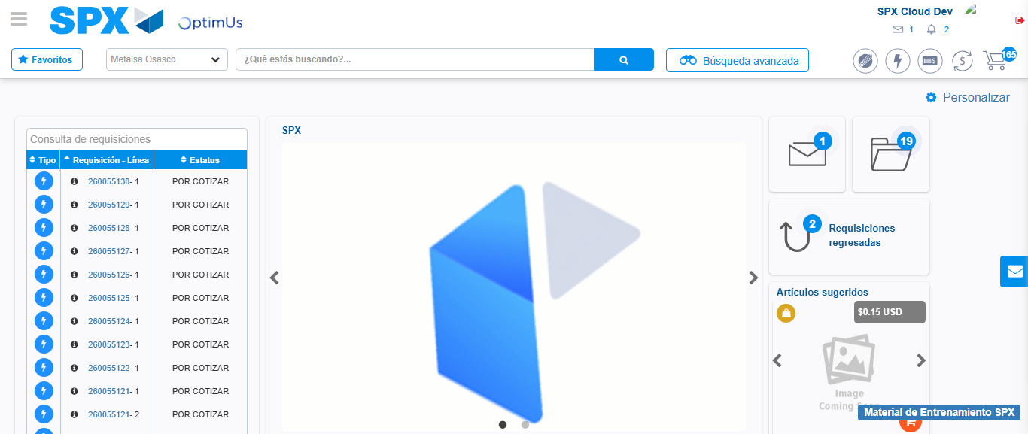Image file-name: QC_Testing-tc002_SPX_Dev5_Crear_Requisicion_Spot_Con_FAD_Tipo_Cobro_CC-1790179208656

Step 9 - Log Out : Log Out SPX
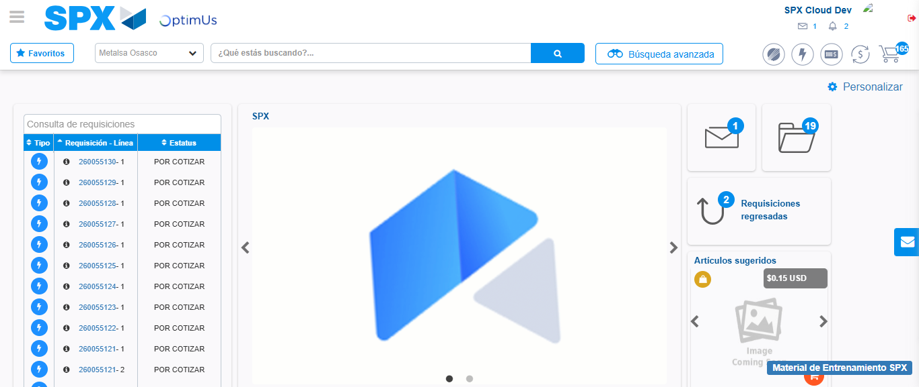Image file-name: QC_Testing-tc002_SPX_Dev5_Crear_Requisicion_Spot_Con_FAD_Tipo_Cobro_CC-1790179208932

